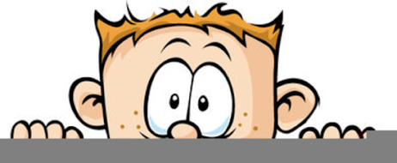

Peek at Our Week
Florida Early Learning and  Developmental Standards | School Activity | Home Extension Activity
Religious Focus: Creation – Day Two  - “Let there be clouds and seas.” | 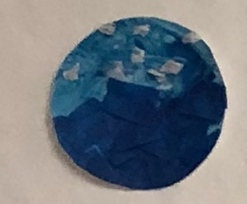  This is an example of what the children will be creating to represent the creation of clouds and seas. | This time of year is great for cloud watching. Go outside and looks at the clouds. Discuss the different shapes, sizes and colors. Look for clouds that resemble objects.
Physical Development  - Shows awareness of safety and increasingly demonstrates knowledge of safe choices and risk assessment when participating in daily activities  - Demonstrates difference between safe and unsafe play behaviors | Safe/Unsafe Playground Rules Game  The children will be shown pictures of safe and unsafe practices on the playground. As a group, they will sort them according to safe or unsafe. | Have a discussion with your child about safe and unsafe practices at your home. Take pictures of your child making safe choice and put them in a small photo album for them to look at.
Social-Emotional Development  - Develops sense of identity and belonging through routines, rituals and interactions  - Initiates and participates in the rituals and routines of the day  - Develops sense of self-awareness and independence | Where does this belong game  Take many different objects from all the centers and one at a time ask the children where they belong. Place each item on a copy of the center label. | This game can be played at home with objects from different rooms in the house, different shelves on a bookcase or objects from different bins.

