Peek at Our Week
Standard Focus | Activity | Home Extension Activity
- Counts and identifies the number sequence “1 to 10”  - Identifies the last number spoken tells “how many” up to five (cardinality)  - Counts sets constructed by the teacher to five and beyond  - Constructs and counts sets of one to five and beyond | 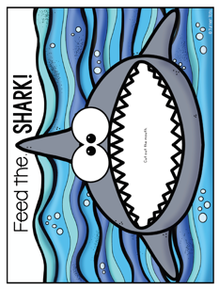  Feed the Shark Game  The children will pick a number card and feed the shark the corresponding number of fish. The child will count the fish and then put them in the shark’s mouth. | 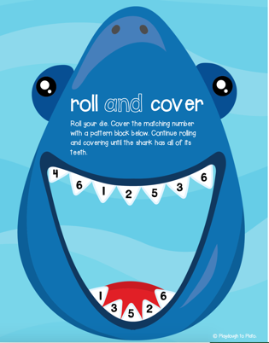  Use the attached sheet to play this Shark Roll and Cover Teeth game.  You can cover the teeth with playdough or paper triangles.
- Increasingly coordinates hand and eye movements to perform a variety of actions with increasing precision | 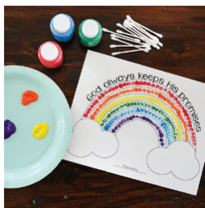  Fruit of the Spirit: faithfulness  The children will be read the story of Noah. They will discuss how the rainbow is a symbol of God’s faithfulness. | Here’s a link to a video telling the story of Noah’s Ark.  4 Noah's Ark by Care Bear's Bible Stories for Kids
- Increasingly coordinates hand and eye movements to perform a variety of actions with increasing precision  - Self Help Skill Focus | Various types of lunch containers will be added to the sensory bins and dramatic play areas so the children can practice opening and closing them. | Practicing skills when they are not currently needed makes it a game. The only way child learn self-help skills is through example and experience. For instance, practicing zipping and unzipping a lunch box while pretending to get ready for school. Try giving your child some zip lock bags to fill up with small objects such as cars. This way when they open it and all the cars come spilling out, they have not lost a bag of food.
Parent Resources: Fruit of the Spirit is Faithfulness.

