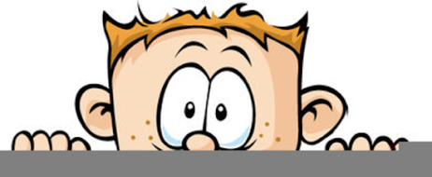

Peek at Our Week
Standard Focus | Activity | Home Extension Activity
- Demonstrates knowledge related to living things and their environments  - Begins to notice the similarities and differences among various living things | 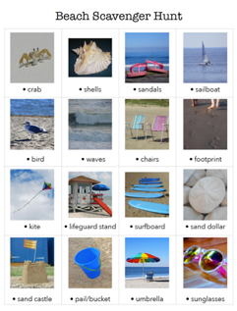  Beach Scavenger Hunt | Book scavenger hunts can be fun and can keep your child’s focus while reading. Pick a book and just look at the front and back cover. Then with your child make a list of items they think might be in the book. Talk about why they think they will see these items. While reading the book, look for the items in the picture and mark any off of the list. After reading the book, count how many were found.
- Uses size words to label objects | 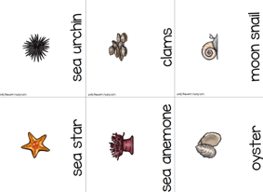  Ocean Life Sorting by Size Game | Get out all those shells you have collected at the beach and sort them by size, color, texture, etc. If you don’t have shell, they can be bought at the Dollar Tree. You could also go outside and collect acorns, leaves, rocks, etc. and then sort those items.
- PERSISTENCE  - Sustains attention for brief periods and finds help when needed  - Increasingly coordinates hand and eye movements to perform a variety of actions with increasing precision  - Uses hand-eye coordination to manipulate objects | 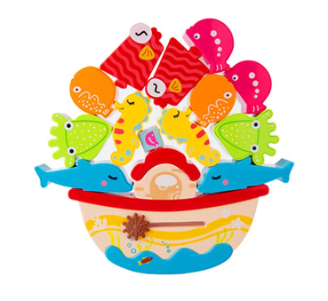  Balancing Puzzles  Each child is given a balancing puzzle to work on. The children are encouraged to not give up. When they get frustrated, they are asked to take a couple deep breaths and try a different way. We say, “Don’t get frustrated, get brave!” | Balancing or Stacking puzzle are one of the best ways I have found to teach persistence, how to handle getting frustrated, and trying alternative strategies. I strongly suggest getting a couple different types of these puzzles. You find them on Amazon starting at around $10. Seeing your child’s face when they have successfully completed one is worth every penny!
Parent Resources:

