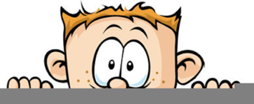

Peek at Our Week
Standard Focus | Activity | Home Extension Activity
- Faith Formation: Fruits of the Spirit - Kindness | 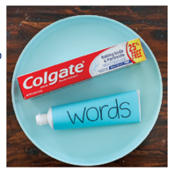  Using a travel size tube of toothpaste, invite your kids to squeeze out the toothpaste onto the plate.  Once they have emptied the toothpaste onto the plate tell them that now their job is to put it all back in the tube. Explain that the toothpaste is just like the words that come out of our mouth. Our words have the power to lift people up or tear them down. If we are not careful, hurtful words can spill out of our mouth and we can’t take them back. You can’t put words back into your mouth just like you can’t put the toothpaste back into the tube. | See the back of this page for a list of Random Acts of Kindness you can do with your family.
- Uses various drawing and art tools with developing coordination | 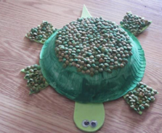  Turtle Craft | 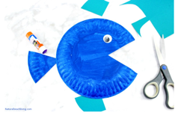  The possibilities for paper plate crafts is endless. Google it and you find everything from fish to bunnies. This is a very simple fish craft. Paint the plate any color, cut the wedge out for the mouth and glue it on as the tail. Finally add a googly eye and you have a fish. You can fancy it up with glitter, tissue paper, circle stickers, just use let your child use their imagination.
- Begins to notice the similarities and differences among various living things such as how they move  - Engages in individual and group movement activities to express and represent thoughts, observations, imagination, feelings, experiences and knowledge | Ocean Movement Cards  The children will be asked to move like ocean creatures, such as crab walk, jump like a dolphin or wiggle like a jellyfish. | Attached is a set of Ocean movement cards for you and your child to enjoy at home.

