Peek at Our Week
Standard Focus | Activity | Home Extension Activity
- Faith Formation: Fruits of the Spirit - Patience | 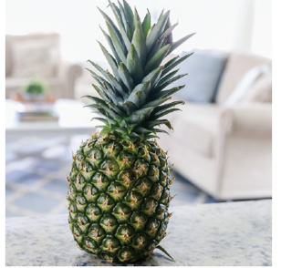  Give the children some small blueberries to eat. Then prepare the pineapple to be eaten. Talk about how long it is taking to get the pineapple ready to eat. Talk about being patient while waiting. | See the back of this page for a patience activity you can do at home.
- Counts and identifies the number sequence “1 to 10” | Goldfish Counting: Have the children count the number of fish in the picture and then count that same number of Goldfish crackers to eat.  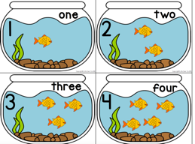 | Next time you give your child Goldfish cracker for snack, also give them some dice. Have them roll the dice then count the dots and then eat the corresponding number of crackers.
- Uses various drawing and art tools with developing coordination | 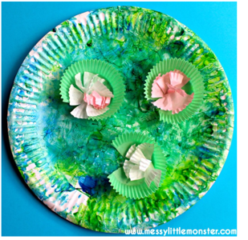  Provide the children with various shades of blue and green paint and sponge brushes. After painting the plate give the children small green and pink or purple cupcake liners and frog sticker and have them glue them on their pond. | Life at the Pond's Edge by Illinois Nature  Here is a link to an fun video about pond life.
Parent Resources:

