Peek at Our Week

Standard Focus | Activity | Home Extension Activity
- Gross Motor Perception (Sensorimotor)  - Uses perceptual information to guide motions and interactions with objects and other people | gluing shades of green to make the frog from Brown Bear, Brown bear what do you see? | A gluing activity your child can do is glue red buttons, red tissue paper, red foam cubes and red toy animals onto red paper.
- Begins to identify own personal space  - Explores own environment  - Begins to use simple tools to explore and observe (e.g., magnifiers, spoons)  - Uses increasingly complex size words to accurately describe objects | Green scavenger hunt *children will search for green objects around the room and after 3 minutes bring back to share what they found. | 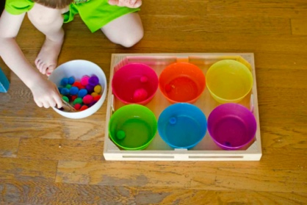  An easy sorting activity is using colored bowls and colored pom poms have your child sort the pom poms into the correct color bowls.
- Responds to an adults simple questions about what is being learned  - Uses imagination and creativity | what color Is the…?  -pictures of objects, ask children what color the object is | A great video to help your child recognize colors is “Pete the cat: I love my white shoes” https://youtu.be/fj_z6zGQVyM

Parent reminder: color of the week is Green

