Peek at Our Week

Standard Focus | Activity | Home Extension Activity
- Responds to an adult’s simple questions about what is being learned  - CREATIVITY AND INVENTIVENESS  - Uses increasingly complex size words to accurately describe objects | painting with red ice. | 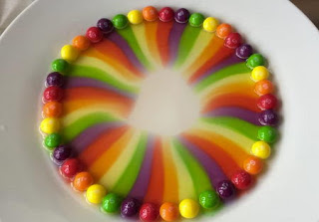  A fun science experiment to do with your child is using skittles line them on a plate, pour hot water in the middle of the plate. The color of the skittles will come off and will make a rainbow.
- Uses perceptual information to guide motions and interactions with objects and other people  - Develops independence through coordinated and purposeful movements and activities | Apple stamping | 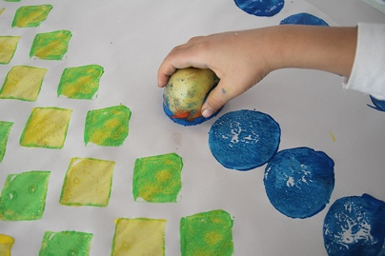  A fun painting activity to do is sponge stamping.
- Produces utterances of three to four units of meaning in length  - Uses increasingly complex size words to accurately describe objects | Red scavenger hunt *children will search for red objects around the room and after 3 minutes bring back to share what they found. | An easy painting activity for your child to do is using an empty toilet paper or paper towel roll stamp it in paint and have your child stamp it on paper.

