Peek at Our Week

Standard Focus | Activity | Home Extension Activity
VII. Social Studies  C. INDIVIDUALS AND GROUPS  1. Identifies differences and similarities of self and others as part of a group | 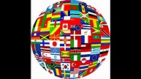  Children understand how we are the same and different from others.  We will discover how we are the same and different by exploring the world Atlas, learning different customs and religions from around the world.  Class Activity:  The children will learn some games from around the world. They are welcome to bring one from a far away land as well. The children will play, 1. Tombola- Italy, 2. Statues- Greece, 3. Corre-Corre La Guarace- Chilie, and 4. Pass the Parcel- United Kingdom | Children enjoying learning how other children live in different parts of the world. We can talk to children about this. We can sing international songs. If your family has a second language that is spoken at home, it is encouraged to keep learning and preserving the customs and cultures.  Home Activity:  YouTube: “French Greeting for children”
VII. Social Studies  A. CULTURE  1. Identifies characteristics of self as an individual | 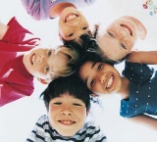  Children understand that their special and unique. The children will be learning that they are special through the bible. 1 Peter 2:9  “ But you are a chosen person, a royal priesthood a holy nation, God’s special possession, that you may declare the praises of him who called you out to darkness into his wonderful light.”  Class Activity:  The children will have available to them a variety of art materials to create unique art. (different shapes and colors of faces, colors of yarn, eyes, ears). The children create their unique persons. | Talk to children about what makes them unique.  Home Activity:  Book Read aloud:  YouTube: Same and Different.  “Same-Same But, different”
VIII. Creative Expression Through the Arts  C. CREATIVE MOVEMENT  1. Continues to engage in individual and group movement activities to express and represent thoughts, observations, imagination, feelings, experiences, and knowledge | 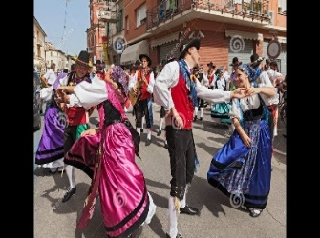  Children will learn and engage in different groups and activities from around the world.  Class Activity:  The children will make a musical instrument that comes from a different part of the world. | Home Activity:  Talk to children about the different flags of the world. Like in the United Nations has with all the unique and colorful flags.  Google- “Flags of the world with names”

Parent Resources: YouTube: “French Greeting for children” YouTube: Same and Different. “Flags of the world with names”

“Same-Same But, different”

Other News:

