Peek at Our Week

Standard Focus | Activity | Home Extension Activity
VI. Scientific Inquiry  A. SCIENTIFIC INQUIRY THROUGH EXPLORATION AND DISCOVERY  1. Uses senses to explore and understand their social and physical environment | 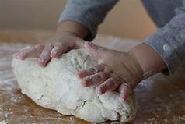  Children use their senses to create and understand different cultures around the world.  Class Activity:  The children will be cooking many foods from around the world. They will be exploring many  ingredients to make foods from scratch. The children will be making Christmas cookies from Italy and Germany.  The children will also be making Pizza bread. | Home Activity:  Italian Pizza Fritta  4 ½ cups of all-purpose flour  I package of dried yeast dissolved in lukewarm water  1 teaspoon of salt  2 Tablespoons of sugar  4 Tablespoons of Olive Oil  - Mix dough till it turns smooth- if sticky. If sticky add a little flour.  - Place in bowel, cover with a dish towel, let rise.  - Tear pieces of and form little flat pizzas  - Heat oil in a pan and fry the little pizzas  - Flip them back and forth in pan till nice.  - Place in a dish, when cooled drizzle powered sugar on them and eat!  (You can substitute sugar and put tomato sauce and favorite pizza toppings and enjoy)
VI. Scientific Inquiry  A. SCIENTIFIC INQUIRY THROUGH EXPLORATION AND DISCOVERY  2. Uses tools in scientific inquiry | Class Activity:  Children will use tools to discover and explore. The children will use measurement tools in order to finish class projects.  The children will weight, and measure butter. I will show then this as a solid and a melted liquid form. The children will understand that the butter is the same amount but, in different ways. | Use different tools to discover and create different experiences.  YouTube:  “Cooking in the Kitchen-Kid song- Pretend Play cooking with fun food for kids
D. EARTH AND SPACE SCIENCE  Benchmark b.  Discovers, explores, sorts, compares, and contrasts objects that are naturally found in the environment, including rocks, soil, sand and mud, and recognizes relationships among the objects (e.g., nature walks with hand lenses, collection bag) (e.g., rocks, twigs, leaves and sea shells) | 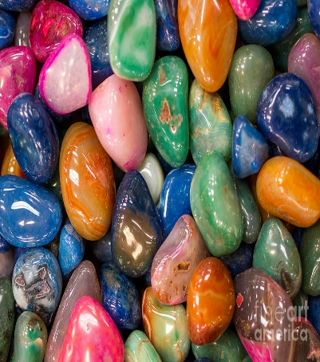  Class Activity:  Children will go on nature walks and explore their findings from outdoors.  The children will use nets, baskets, magnifiers and tweezers for observation and exploration.  The children will be sorting the materials found outdoors and sorting them, they will compare and contrast the items found . We will also chart on graph paper our results. | Have fun exploring with children see what you can find outdoors.  Home Activity:  Watch- YouTube: “The Nature walk”

Parent Resources:
YouTube:
“Cooking in the Kitchen-Kid song- Pretend Play cooking with fun food for kids
YouTube: “The Nature walk”

