Peek at Our Week

Standard Focus | Activity | Home Extension Activity
- C. VOCABULARY  Combines words into three-word sentences to describe the world around them although unfamiliar adults may have difficulty understanding the child  - Begins to describe, compare, sort and classify objects based on observable physical characteristics (e.g., color, sound, weight) | 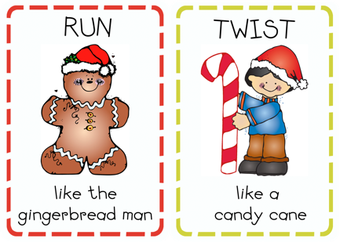  Winter gross motor movement game | Movement for children is very important. some fun movement activities are dancing with ribbon, shaking bells and moving like ocean and land animals. For example... pinching like a crab, stomping like an elephant, running like a horse.
- Develops a sense of awe and wonder, respect, gratitude and stewardship for God’s creation.  - Begins to recognize common symbols in the environment | Painting angels that go on bulletin board around the track | 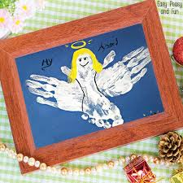  A cute painting activity for your child to do is to paint one of their hands and make an angel out of it.
- Begins to describe, compare, sort and classify objects based on observable physical characteristics (e.g., color, sound, weight)  - LISTENING AND UNDERSTANDING3. Follows directions Benchmark a.  Follows multi-step directions with reminders | 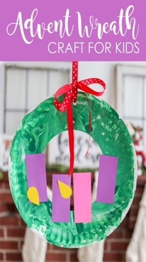  Advent wreath craft  *children will paint a paper plate green, teacher will cut out middle of plate, children will glue purple candles onto plate and yellow wick to make advent wreath. | An activity you can do with your child is making an advent calendar.

Parent resources:

