Peek at Our Week

Standard Focus | Activity | Home Extension Activity
- Shows increased eagerness and curiosity as a learner  - Spends more time engaging in child-initiated activities and seeks and accepts help when encountering a problem  - Takes cues from preferred adult and others to expand their strategies and tools to self-regulate | Creating a road that joseph takes Mary to Bethlehem on using rocks, leaves and cotton balls. | An activity your child could do while at home is draw what they think Mary and Joseph look like and what they think Bethlehem looks like.
- MANAGING EMOTIONS  Demonstrates ability to self-regulate  - SPACES, PLACES AND ENVIRONMENTS Uses words to describe objects in a familiar space  - Begins to engage in a variety of individual and group musical activities  - Develops a sense of awe and wonder, respect, gratitude and stewardship for God’s creation. | Painting a picture for Santa while listening to and singing songs.  *teachers will ask children questions about what they painted and write it down on paper. | A great way for you to help your child use their imagination and be engaged in what they are doing is by asking them questions. When your child draws or paints a picture ask them questions about it and write down what they are telling you. writing in front of children helps to familiarize them with letters.
- Gains control of a variety of postures and movements including stooping, going from sitting to standing, running and jumping  - Attends to sights, sounds, objects, people and activities  - Begins to explore a greater variety of motions with objects (e.g., rotate, spin, twist) | 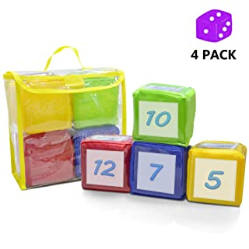  Gross motor movement game using dice with pictures. | Some great movement songs to sing with your child is “Head, Shoulders, knees & Toes” “Freeze Dance” “Open Shut Them” “Shake your sillies out”

Parent Resources:

