Peek at Our Week

Standard Focus | Activity | Home Extension Activity
- Gross Motor Development  - Spends more time engaging in child-initiated activities and seeks and accepts help when encountering a problem  - Combines words into three-word sentences to describe the world around them although unfamiliar adults may have difficulty understanding the child | 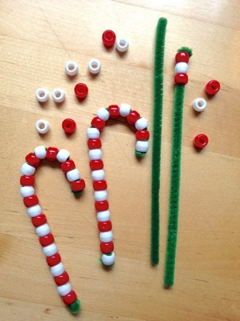  Making candy cane  *give children white and red beads, have them lace the beads on pipe cleaner (supervise very closely) | 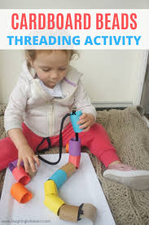  An easy lacing activity for your child to do at home is lacing rolled up paper onto a piece of string or ribbon.
- Develops a sense of awe and wonder, respect, gratitude and stewardship for God’s creation.  - Gains control of a variety of postures and movements including going from sitting to standing | Creating a stable with animals in it (drawling & painting) | Drawling is a wonderful hand eye coordination activity for children. You and your child could draw a Christmas picture and mail it to a relative or soldier.
- Explores the environment with purpose and flexibility  - Continues sustained independent play while participating in more complex activities  Recognizes patterns in the environment | Play dough  *Christmas themed tools | Play-dough is a great fine motor and sensory activity for your child. Here is a recipe to make your own play-dough.  https://www.iheartnaptime.net/play-dough-recipe/

Parent Resources:

