Peek at Our Week

Standard Focus | Activity | Home Extension Activity
- Uses words to describe objects in a familiar space  A. LISTENING AND UNDERSTANDING3. Follows directions Benchmark a.  Follows multi-step directions with reminders  - B. MOTOR DEVELOPMENT  a. Gross Motor Development | Painting with ice that has glitter in it. | An activity you could do with your child is using an ice tray, fill it up with water and add some food coloring or water-based paint, mix It together and freeze it. Describe an object to your child such as a snowflake or a donkey and have them try and paint it. (I recommend doing this activity outside or putting a baking sheet under the paper)
- . MANAGING EMOTIONS  1. Demonstrates ability to self-regulate  C. PHYSICAL SCIENCE  Benchmark a.  - Begins to explore a greater variety of motions with objects (e.g., rotate, spin, twist) | Painting Mary  *place a picture of Mary on wall and have children try and paint her. | 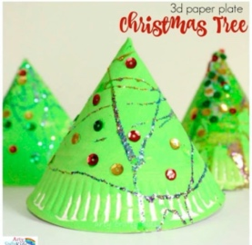  this is a great art project to do with your child that has benefits of them using their fine motor skills. For this project you have your child paint a plate, you staple the plate together to make a cone and have your child glue decorations onto it.
- HEALTH AND WELLBEING  d. Feeding and Nutrition  1. Responds to feeding or feeds self with increasing efficiency and demonstrates increasing interest in eating habits and making food choices  Benchmark a.  Feeds self a wide variety of foods using developmentally appropriate basic utensils | 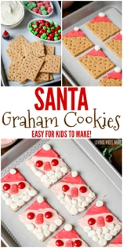  Cooking activity - make Santa graham cracker cookies. | Cooking is a great activity to do with your child that helps them practice math concepts and language skills. An easy thing that young children can make is Mac & Cheese.
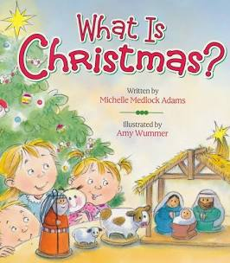
Parent Resources: A great book to read with your child is “What is Christmas?” this book can be purchased from Target.

