Peek at Our Week

Standard Focus | Activity | Home Extension Activity
IV. Language and Literacy  3. Follows directions | Children continue to follow directions. | Keep practicing following directions.  Following directions games:  - Simon the game and Simon says.  - Red light green light.
IV. Language and Literacy.  Bench Achieves mastery of two-step directions and usually follows three-step directions  mark a. | 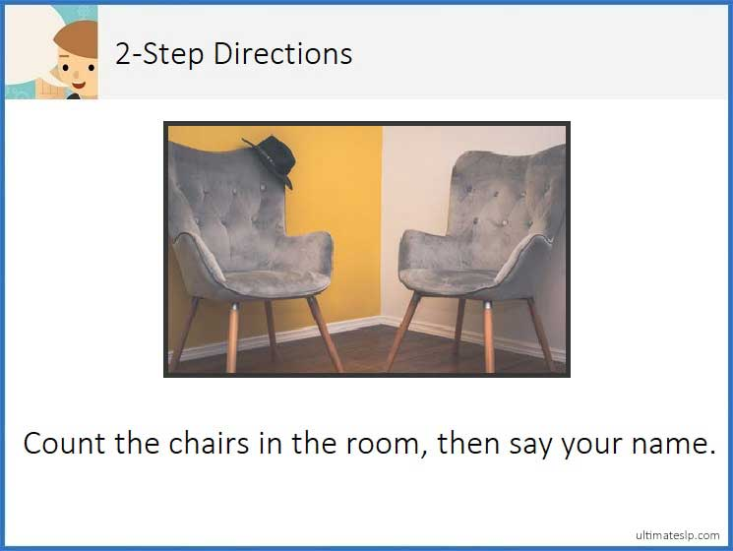  Children master two-step directions. | Practice with children, ask them one step and two step directions.
V. Mathematical Thinking C. PATTERNS  1. Identifies and extends a simple AB repeating pattern  2. Duplicates a simple AB pattern using different objects  3. Recognizes the unit of repeat of a more complex pattern and extends the pattern (e.g., ABB or ABC) | 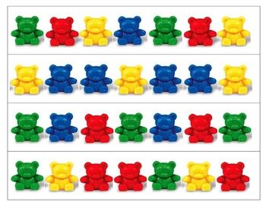  Children continue to learn math concepts and patterns. | Practice patterns at home.  This can be done with different household objects.  (paper clips, bottle tops, crayons and change.)

Parent Resources:

Other News:

