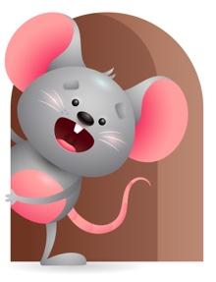
Peek at Our Week

Standard Focus | Activity | Home Extension Activity
Creative Expression-Younger & Older- Responds to different forms of art. | Younger & Older- Put ice cubes in a plastic jar and let them watch it melt and turn into water. Using water let them paint on blue paper. | Younger & Older- While taking a bath let them splash in the water. Let them fill and dump cups of water.
Social Studies-Younger- Begins to recognize family members. Older-Begins to explore characteristics of self (eyes, nose, and hair). | Younger- show them different pictures of things that need water-plants, animals, people. Older- Practice washing hands with soap and water. Tell them how important it is to keep ourselves clean. | Younger- Show them pictures of different family members who did something with them-like took them to the park, went to the beach, had a picnic, took them for a walk, played outside with them. The more they see them they will recognize who they are.
Scientific Inquiry-Younger & Older- Uses senses to gain knowledge about objects. Displays interest in various types of materials (water, soft fabric, textured carpet. | Younger & Older-Play in water and add a variety of objects to it- boats, animals, cups, soap to make bubbles, food color to change the color of the water. | Younger & Older- Explore with them at home the many things you can do with water- take a bath, water flowers and plants, paint, drink, add soap to it, fill up buckets, wash hands. They will not understand all that but let them practice touching the water and washing with it.

Parent Resources

Other News-

