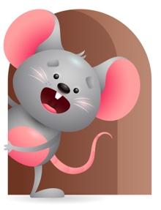
Peek at Our Week

Standard Focus | Activity | Home Extension Activity
Mathematical Thinking- Younger-Explores objects in hands. Older-Explores objects with different characteristics. | Younger- Put objects in a bucket and add water for them to play. (cups, boats, bowls, blocks). Older- Explore objects like sandpaper, hard blocks, soft animals, textured balls. | Younger- Let them play with toys while you give them a bath. Older- Give them things to feel that are hard, soft, rough, bumpy. When bathing you can ask how does the water feel? (Hot, warm, cold). Does it feel soft on your skin?
Language and Literacy-Younger-Uses increased vocabulary including babbling consonant-like sounds. Older- Shows an understanding of words and their meanings. | Younger- Read and sing Five little ducks and name what you see and what they are doing. (make duck sounds). Older-Read and sing five Green and speckled frogs and name what you see and what they are doing. (make frog sounds). | Younger- Make different sounds to see if they will do it back. Read and sing to them so they can hear different sounds. Older- Name objects in your house and tell them what it is and what it does. Through repetition they will start to understand words and their meanings.
Social and Emotional-Younger & Older- Develops sense of identity and belonging through routines, rituals, and interactions. | Younger & Older-While interacting through play let them feel warm and cold water and see what ice cubes look like and how they sound when you shake them in a cup. | Younger & Older- Interact with them so they gain a sense of belonging and identity. Use their name and say things like this is (child’s name) blanket, bed, cup, toys. Keep your same routines for playing, eating, sleeping.

Parent Resources

Other News-

