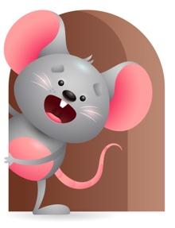
Peek at Our Week

Standard Focus | Activity | Home Extension Activity
Approaches to Learning-Younger-Persistence- Attends to sounds. Older-Shows awareness of and interest in the environment. | Younger- Listen to all the sounds the toys make. When washing your hands listen to the running water. Older- listen and dance to the music splish splash I was taking a bath, rain, rain go away, it’s raining, it’s pouring. | Younger- Interact with them and do things more then once. They will learn more through repetition. Older- give them things they like to play with that will keep their interest.
Physical Development- Younger & Older-Feeding and Nutrition. | Younger & Older- Younger-Let them practice holding their bottles and taking food off the spoon with their lips. Older- Practice picking up food and feeding themselves. Practice drinking water from their cups. | Younger & Older- Give them healthy choices at home and let them practice picking up food and trying different things to eat. Practice holding bottles and letting them drink from cups. Practice good hand washing before and after eating.
Creative Expression- Younger & Older- Responds to music in a variety of ways. | Younger & Older- While playing musical instruments sing and dance to Row, Row, Row your boat, Rise and Shine, Itsy Bitsy Spider. | Younger & Older- Put on some music and sing, dance, move around. Give them bells, drums, pots and pans, spoons, anything that makes a sound. Have fun with it and make your own band.

Parent Resources

Other News-

