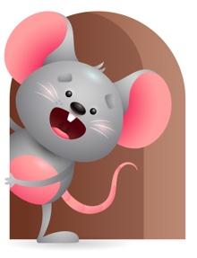
Peek at Our Week

Standard Focus | Activity | Home Extension Activity
Language and Literacy-Younger- Listening and understanding. Older- Shows an understanding of words and their meaning. | Younger- Read the books-Put me in the zoo and Go dog go. Show them the pictures and tell them what is happening. Older- Read Old McDonald had a Farm and use the farm animals to show them what a pig, cow, horse, and chicken looks like and make the sound for each one. | Younger- Read different books to them and tell them what is happening in the book, you can play music or sing to them and they will listen and start to understand. Older- Start telling them the names of objects. This is a car, truck, block, book, bed. Tell them the meaning of the word. Car is what we ride in, bed is where you sleep, book is for reading.
Approaches to Learning-Younger- Eagerness and curiosity. Older-Shows interest and excitement about people and objects. | Younger- Give them a variety of animals and watch to see what they do. Older- Using all the different animals read Cows in the kitchen and have fun using their name and making all the sounds. Have fun with it. | Younger& Older- Get their curiosity going by giving them things that make sounds and have lights. Musical toys and instruments. Watch them as they are eager and curious how they work. Get on the floor with them and help them to figure it out, add some farm, zoo, circus, or stuffed animals you might have. Name each one and make their sound.
Social Emotional-Younger- Responds to a range of emotions. Older- Demonstrates ability to self-regulate. | Younger- Play with puppets and do facial emotions-Happy, sad, mad, tired, excited. Then use their name and say I see (child’s name) is Happy today, sad, mad, tired, or excited. Older- Use puppets to make facial expressions and see if they will do it with you. | Younger & Older- Help them to respond to emotions and to be able to comfort themselves. Make a happy face and tell them I’m happy I have my bottle, I’m sad I need my blanket, I’m tired I need to go to bed, I’m excited because I have all these toys to play with.

Parent Resources

Other News-

