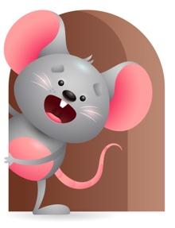
Peek at Our Week

Standard Focus | Activity | Home Extension Activity
Approaches to Learning-Younger-Eagerness and Curiosity. Older-Shows interest in people. | Younger-Provide toys that roll, make sounds, and are colorful and let them explore what they can do with them. Give them soft play animals that they can chew on for their senses. Older- Sit and interact with them on the floor. Name animals and make their sounds. | Younger- Give them colorful and exciting things to explore. They are so eager to do things at this age. If you are out, try stopping at a pet store and let them see the animals and fish. If you have pets at home talk about them. Older- Interact with them when they play, they love the company.
Scientific Inquiry-Younger-Uses senses to explore and understand their social and physical environment. Older-relates to living things in the environment. | Younger- While exploring and understanding their environment they will use their senses to explore the objects and people around them. (mouthing, touching, shaking, and dropping. Older-Read books and talk about the different animals that live with them, in the zoo, on a farm, in the circus. Read- Put me in the zoo, Go dog Go, Brown Bear Brown Bear. | Younger- Let them play with things they can explore their senses with. (rubber toys, textured materials, cold teethers). Older- Talk about all the different animals you see in the zoo, circus, farm, pet shop, and in your home. Show them pictures if you have any.
Creative Expression Younger & Older- Imaginative and creative play. | Younger & Older- Make a farm using blocks and put a fence around it and pretend you are the farmer taking care of all the animals-feed and water them, give them a bath, put them in the barn for the night. | Younger & Older- Continue to give them creative play-pretend your fishing, feeding animals, watching birds fly and squirrels run around, watching monkeys climb trees. They will not understand but they will enjoy being creative with you.

Parent Resources

Other News-

