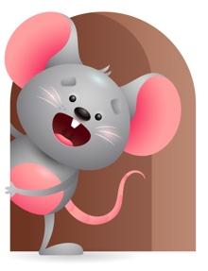
Peek at Our Week

Standard Focus | Activity | Home Extension Activity
Scientific Inquiry-Younger-Uses senses to explore and understand their social and physical environment. Older-Demonstrates knowledge related to living things and their environments. | Younger- Read Old McDonald had a farm and let them see the pictures of the animals and tell them the sound they make. Older- Talk to them about what the farm animals’ names are. Where do they live? What do they eat? What color are they? | Younger & Older- Talk about the animals you have at home- dogs, cats, birds. Some of you might even have a farm with chickens, cows, ducks, pigs. Talk about what they eat and what they do. Cows give milk, chickens lay eggs. Make animal sounds for them.
Social Studies-Younger- Begins to respond to schedules. Older-Culture-Experiences own family practices (language). | Younger- They begin to know when you sit on the floor its play time, pull the highchair out it is time to eat, turn out lights we sleep, put on music we sing and dance. Older-Talk to them in their own language and they will start to understand the words you use when talking. They listen to sounds and sometimes repeat them. | Younger- At home try and do things at the same time each day and stay on schedule with routines like- eating, sleeping, playing. They will begin to respond to Schedules through repetition. Older-Practice the language you use at home so they can start to hear sounds and understand the words you use. If you know it, you can even try a little sign language.
Creative Expression- Younger & Older- Responds spontaneously to different forms of art in the environment. | Younger & Older- We will be creative and build with blocks, put paint in a jar and add a rock or seashell and shake it up, finger paint with baby food. | Younger & Older- Continue to be creative at home-paint on paper, shells, rocks, boxes. Let them smear baby food when they eat for a great sensory skill-you can also use cool whip, pudding, or jello. Get messy and have fun.

Parent Resources

Other News- We will continue to do our traditional prayers including the sign of the cross, daily and table prayers, listen to Bible Stories, recognizes that prayer is talking to God, and we will add knows that God loves, protects and provides for them.

