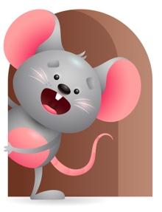
Peek at Our Week

Standard Focus | Activity | Home Extension Activity
Social Studies-Younger- Begins to respond to time and change. Older- Experiences traditions and celebrations. | Younger- We will sing songs that will help them know what time it is- Nap time-are you sleeping? Lunch-I like to eat, eat, eat, apples and bananas, Play-the more we get together. Older-Do art projects for the holidays and keep with traditions. | Younger-while home try and do things at the same time so they will know that it is time for- Nap, lunch, play, bath, and bed. Older- Let them experience your traditions and celebrations by doing something that you always do for Birthdays, Easter, Thanksgiving, or Christmas.
Creative Expression-Younger & Older- Imaginative and creative play. | Younger & Older-Play with farm animals and pretend to feed and water them, give them a bath, make a fenced in yard and a barn using blocks. Play with farm animal puppets and make the sounds for them and say their names. This will build on their imagination. | Younger & Older- Continue to build on their imagination and be creative- using blocks or boxes make a house and use baby dolls to pretend you are feeding them, rocking them, giving them a bath. Extend it more by using stuffed animals or puppets and take care of them as if it were your pet.
Physical Development-Younger- Demonstrates increasing strength and coordination when using hand muscles. Older- Active physical play-increases balance and coordination. | Younger- Practice doing hand motions as you sing Happy and you know it. Put a basket of toys on the floor and let them practice reaching and grasping them in their hands. Older- While interacting on the floor practice balance and coordination- see if they can walk holding toys in their hands, stack blocks without letting them fall, stand in the middle of the room without holding on to anything. | Younger- Let them practice holding their bottle, and then let them try cups and finger foods. Give them things that make them use their hand muscles for. Older- Let them practice standing alone, walking, stacking things, pushing and rolling toys.

Parent Resources

Other News-

