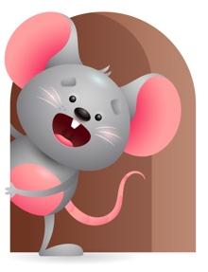
Peek at Our Week

Standard Focus | Activity | Home Extension Activity
Physical Development-Younger- Explores new body positions and movements-rolling over, sitting, crawling, hitting/kicking at objects. Older- Engages in physical activities with increasing balance, and coordination. | Younger- Tummy and floor time-practices crawling, rolling over from stomach to back, sitting with or without help, kicking at objects, and using muscles to raise their heads up. Older- While practicing position words- we will climb up and down slide, Crawl under the crib, go behind the chair, sit next to our friends. | Younger- Continue to help your child roll over, sit, crawl, raise their head. Put things in front of them that will encourage them to move and reach for. Older- Practice position words with them -do things that make you go in and out, up and down, on and off, outside, inside, over and under. Make a great learning experience out of it.
Social Studies-Younger- Begins to explore self- eyes, ears, nose, mouth. Older- Uses senses to solve problems. | Younger- Point to your body parts and name them and say what they do- eyes-see-nose-smells-mouth-taste-ears-hear. Older- while playing they start to see how things work- we will show them how plastic eggs come apart and how you can fill them with objects. Then we will see how many can fit in a bucket. | Younger- Continue to name body parts and say what they do. Repetition is the best way for them to learn. Sing head, shoulders, knees and toes-eyes and ears and mouth and nose-point to the part as you sing. Older- Help them to see how things work-balls bounce, cars roll, blocks stack and fall.
Scientific Inquiry-Younger- Notices cause and effect. Older- Uses senses to gain knowledge about objects. | Younger- Play with the pop- up toys and name the object that pops up and the sound it makes. Older- roll the cars across the floor and let them watch them go and then stop. | Younger & Older- Play and have fun and let them explore how objects sound, pop-up, move, spin, stop, stack, fall.

Parent Resources

Other News-

