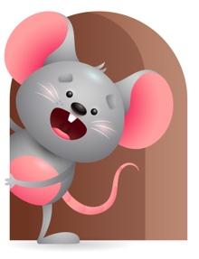
Peek at Our Week

Standard Focus | Activity | Home Extension Activity
Approaches to Learning-Younger- Shows awareness of and interest in the environment. Older- Persistence- tries to produce pleasurable outcomes. | Younger- Explores the environment and shows excitement in playing one on one with people and familiar objects. Older- Sing as you read the book Jesus Loves Me -Read it over again and talk about how Jesus Loves them. Read When Jesus was a little Boy and talk about some of the things he did. | Younger- Let them explore their home environment-interact with them and play with familiar objects. Older- Do things more then once. Be persistence- roll ball back and forth for a while, stack blocks 5-6 times, read books more than once, sing the same song over again.
Physical Development-Younger- Demonstrates use of large muscles for movement, position, strength, and coordination. Older- Active physical play- Engages in physical activities with increasing balance, and coordination. | Younger- We will practice using our hand muscles to play and hold on to our bottles and reach for the toys and hold them in our hands to develop increasing strength. Older- We will practice crawling, standing, pulling up on things and taking a few steps. Crawl under things, ride the tractor, pull up on cribs. | Younger- give them things they must grip to hold on to. Let them reach and stretch for toys they want, hold their bottle when feeding. This will help their strength and coordination. Older-Practice letting them crawl, sit up with or without help, pull up on things, and stand holding on to something. These things will help their balance and coordination.
Creative Expression-Younger& Older- Music-responds to music in a variety of ways- Creative movement-uses movement to show increasing body awareness in response to own environment. | Younger & Older- play musical instruments and move around the room- clap your hands-slap your knees-bounce up and down- can you put your instrument up in the air? Behind your back? On your knees? Under your legs? | Younger & Older-Continue to enjoy music with them and get them to do things that are fun- shake your body, wiggle your fingers, bounce up and down, sing with them. Have fun with music.

Parent Resources

Other News-

