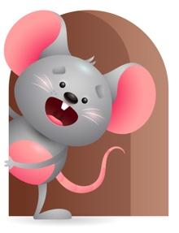
Peek at Our Week

Standard Focus | Activity | Home Extension Activity
Language and Literacy-Younger- Increases knowledge through listening. Older-Demonstrates understanding when listening. | Younger- While playing with the musical table they turn their head towards the sounds and voices they hear. Older- While interacting they start to respond to your directions when you say-get the ball and roll it to me, put the blocks in the bucket. | Younger & Older- Continue to talk to them and play music and make sounds. Give them simple directions to respond to. This will help their listening and understanding skills.
Social and Emotional- Younger- Managing Emotions- ability to self-regulate. Older--- Attends to sights, sounds, objects, people and activities. | Younger- Through the day they look for adult to help soothe them. They realize how to get their needs met through crying when wet or hungry. Older- Play games like Clap, Clap, Clap your hands-Wiggle, Wiggle, Wiggle your fingers- Rub, Rub, Rub your hands Blink, Blink, Blink your eyes-Touch, Touch, Touch your nose. | Younger- Look in a mirror with your child and show them what it looks like to be Happy-Sad- Mad. Help to manage their emotions through comforting them and meeting their needs. Older-Play games with them and interact in play- they will love spending time with you doing activities or listening to music and making sounds. Have Fun.
Approaches to Learning -Younger- Shows awareness of and interest in the environment. Older-Attends to sights, sounds, and people for brief and increasing periods of time and tries to produce interesting and pleasurable outcomes. | Younger- Loves to interact with Teacher and enjoys looking in a mirror and making sounds at their image. Shows interest in the things around them. Older- Play musical instruments and let them hear the sounds they make. Let them try to use them and have fun. | Younger- Continue to interact with them and do things that keep their interest-read, sing, play. Older- Go for a walk and look at the people and sights you might see. Listen to the sounds you might hear- birds singing- cars going by- wind blowing. Make it a pleasurable and interesting.

Parent Resources

Other News-

