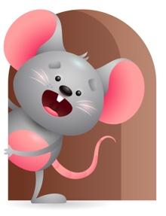
Peek at Our Week

Standard Focus | Activity | Home Extension Activity
Social Studies-Younger- Begins to explore characteristics of self (eyes, nose, and hair). Older-Responds to people and objects. | Younger- Begins to explore what their body parts can do. Play pat-a-cake and peek-a-boo and do the hand motions. Older- Play with buckets and eggs to see what you can do with them. Fill and dump the bucket, roll the eggs across the floor, fill the eggs with different objects and listen to the sounds they make. | Younger- Continue to let them explore their body parts and what they can do with them. Tell them these are your hands to help you hold your bottle, these are your ears to hear me sing, these are your eyes to see everyone around you. Older- Continue to let them explore objects to see what they can do- cars roll, balls bounce, blocks stack.
Scientific Inquiry-Younger- Notices cause and effect (crying to get needs met). Older- Displays interest in the movement of objects. | Younger- Play with pop up toy- when you push the button or turn the knob, they will see that something happens or pops up. Older- Watches objects move and stop and is curious how they work and tries to explore to see how to do it. | Younger- Give them things to play with that have cause and effect- pop up toys, wind up, jack in a box. Older- Give them things that move and stop and let them explore it to see how it works.
Mathematical Thinking-Younger- Explores the properties of objects and watches how they move. Older- Explores objects in various ways. | Younger- Tummy Time- plays with toys and watches how they work and move-reaches for a toy and shakes it to see what it does. Older- Play with blocks and see how many things you can do with them- stack them, line them up, count them, see how many will fill a bucket. | Younger- Let them explore as they play to see how objects move and work. Older- Continue to let them explore how many things they can do with an object- stack, roll, count, fill a bucket, paint.

Parent Resources

Other News- We will continue to learn Traditional Prayers including the Sign of the Cross, Daily and Table Prayers, listens to Bible Stories, and now we will add Recognizes that Prayer is Talking to God.

