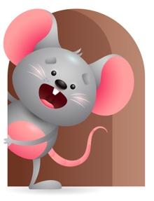
Peek at Our Week

Standard Focus | Activity | Home Extension Activity
Social Studies- Younger & Older- Begins to respond to schedules. | Younger- Begins to know when it is time to change diapers, play time, nap time, bottle time, so make it pleasurable. Interact at play, rock them and pat backs at nap, sing at diaper changing time, let them practice holding bottles at lunch time. Older Do the same with them only let them practice picking up finger foods and holding their cups at lunch. | Younger & Older- Try to do the same things at the same time so you can have a routine for them. Make it fun and pleasurable for them to have a schedule. Sing to them throughout the day and talk to them in a soft voice.
Creative Expression-Younger- Responds to music in a variety of ways. Older-Respond spontaneously to different forms of art in the environment. | Younger- Starts to enjoy music- Sing Jesus Loves the little children-Baa Baa Black Sheep. Clap your hands and move all around as you sing. Older- Let them finger paint on paper with different colors. Roll colored tissue paper up into balls and play with it. | Younger- Sing to them all through the day and give them things they can use for musical instruments. Pots and pans, bells, toy drums, rattles, anything that makes a sound. Dance and move around and have fun. Older- Give them things they can explore colors on. Let them paint on paper, boxes, or just let them smear it on their highchair lid.
Physical Development- Younger- Begins to use hands for reaching and grasping toys and holding bottles. Older- Feeding and Nutrition-responds to feeding self. | Younger- While reaching and picking up toys we will help them shake it or squeeze it to increase their hand strength. Older-Practice picking up foods with their fingers and hands. Give them a variety of different color foods to make it look inviting. | Younger -Give them squeeze toys so they can practice shaking and squeezing them to strengthen their hand muscles. Older- Give them lots of different color foods to practice picking up and feeding themselves,

Parent Resources

Other News-

