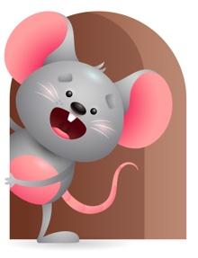
Peek at Our Week

Standard Focus | Activity | Home Extension Activity
Approaches to Learning-Younger- Shows interest in the environment. Older- Shows interest and excitement with familiar people, and objects. | Younger- while interacting with Teacher they will explore all the things they see around the room (pop-up toys, rattles, musical toys, books). Older- Listens to the sounds that things make and tries to see how they work (cars, musical books, toys). | Younger- Let them explore different things around the house and tell them what it is.(pots pans, spoons ,beds, floors) Go outside and feel the grass, sand, flowers, trees. Older- Give them toys that have sounds or lights up and let them see how it works.
Language and Literacy-Younger- Increases knowledge through listening. Older- Responds to adult reading a book. | Younger- Sing and Read the Book-This little light of mine- as they listen they will turn their head towards the sound. Older- Sing and Read book-Jesus Loves me. Tell them a little story about how Jesus loves them. | Younger- Let them listen to different kinds of tapes and music. Read to them on a daily basis and name the things in the book and make animal sounds. They learn through listening. Older- Continue to read to them and tell them stories. They enjoy you reading.
Social Studies-Younger- Recognizes familiar people and objects. Older-Begins to explore characteristics of self ( eyes, nose, hair). | Younger- Begins to recognize who the teacher is and the people around them. Plays with familiar people and objects. Older- Ask questions like what do your eyes do? Ears? Mouth? Nose? | Younger- Look in a photo album and show them familiar family members and pets-tell them who it is. Older- Point to your body parts and tell them this is your (Hair, eyes, nose, mouth, hands, feet). Tell them what each part does(eyes-see-ears-hear).

Parent Resources

Other News-

