Standard Focus | Activity | Home Extension Activity
V. Mathematical Thinking E. SPATIAL RELATIONS 1. Begins to demonstrate an understanding of basic spatial directions through songs, finger plays and games 2. Manipulates objects by flipping, sliding and rotating to make them fit F. MEASUREMENT AND DATA 1. Uses increasingly complex size words to accurately describe objects 2. Compares sets of objects by one attribute (e.g., sort by size) | Nest and Tunnels with blocks  Children will build different size tunnels and nest for various animals as we read Over in the Meadow and Scoot! | Build nest and tunnels at home. Use furniture and sheets to build tunnels and piles of pillows and blankets for nest.  Ask your child How they will build and What they will need to support planning. Cuddle up in the nest with your little one and read books about different animals and where they live or your child’s favorite book.
VIII. Creative Expression Through the Arts A. SENSORY ART EXPERIENCE 1. Uses imagination and creativity to express self through open-ended, diverse and process-oriented art experiences with intention | Torn Paper Cat tails- Children will develop their pincher grip and eye hand coordination while tearing paper. Children will glue the torn paper to create the cat tails for our class pond mural. | Tear up newspaper and other thicknesses of paper to develop your child’s pincher grip. Once you have torn up the paper glue pieces on to another paper to create a unique work of art.
IV. Language and Literacy C. VOCABULARY 1. Shows an understanding of words and their meanings (receptive) Benchmark a. Responds appropriately to almost all adult speech including requests involving multiple steps Benchmark b. Demonstrates understanding of words across varied topics, including words or lines from books, songs and stories, as well as body parts (typically understands between 500-900 words) E. CONVERSATION 1. Uses verbal and nonverbal communication and language to express needs and feelings, share experiences and resolve problems Benchmark a. Engages in conversations using words, signs, two- or three-word phrases, or simple sentences to initiate, continue or extend conversations with others  III. Social and Emotional Development D. SENSE OF IDENTITY AND BELONGING 4. Develops sense of self-awareness and independence Benchmark b. Communicates verbally or nonverbally own preferences  F. MEASUREMENT AND DATA 1. Uses increasingly complex size words to accurately describe objects 2. Compares sets of objects by one attribute (e.g., sort by size) | Dramatic Play- Picnic at the Pond  Fill picnic basket with items matching the picture order shown on the wall. Model words First, Next, Then  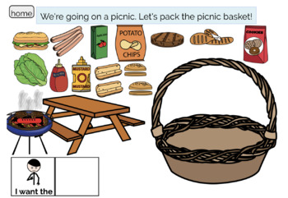 | Go for a real picnic with your child near a pond. Have your child help decide what items to take on the picnic and help you pack the basket.
Parent Resources:

