Standard Focus | Activity | Home Extension Activity
VI. Scientific Inquiry  B. LIFE SCIENCE  1. Demonstrates knowledge related to living things and their environments  Benchmark a. Explores, interacts with and identifies a growing number and variety of plants and animals  Benchmark b. Begins to explore how plants and animals grow and change (e.g., baby chicks grow to be chickens and puppies grow to be dogs) | Sprouting Lima beans in a bag experiment  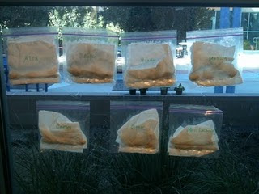 | Lima Bean in a bag experiment kit for home.  This is a fun and easy experiment you can do with your children. Tape the partly open bag in a window that receives sunlight every day and keep the paper towel moist, but not flooded. Discuss the changes you see with your child every day.
V. Mathematical Thinking  F. MEASUREMENT AND DATA  1. Uses increasingly complex size words to accurately describe objects 2. Compares sets of objects by one attribute (e.g., sort by size) Big to Little and Little to Big | 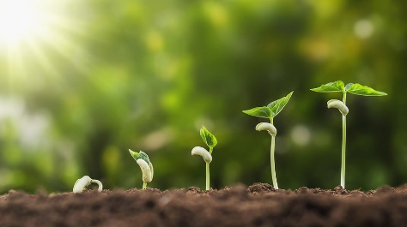 | At home have children sort up to five items by size such as pots, dishes, family clothing, etc. encourage the use of alternate words such as Big, Large, huge, tiny, small, little to build vocabulary.
III. Social and Emotional Development  D. SENSE OF IDENTITY AND BELONGING  4. Develops sense of self-awareness and independence | Self- Help/Health- Lunch time routine: getting my lunchbox and paper towel, Putting on my socks and shoes. | Practice independence by teaching your child to put on their socks and shoes then encourage them to do it on their own. Encourage them to keep trying even when they may want to give up.

