Standard Focus | Activity | Home Extension Activity
IV. Language and Literacy  C. VOCABULARY  1. Shows an understanding of words and their meanings (receptive) Benchmark a. Responds appropriately to almost all adult speech including requests involving multiple steps Benchmark  b. Demonstrates understanding of words across varied topics, including words or lines from books, songs and stories, as well as body parts (typically understands between 500-900 words) | Read the Very Hungry Caterpillar repeating key words and phrases from the book  Focus on: Names of Food eaten  Days of the week  Number words 1-5  Phrase: “He was Still hungry”  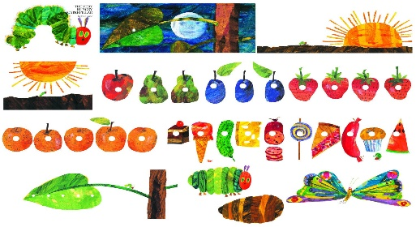  This Photo by Unknown Author is licensed under CC BY-SA | 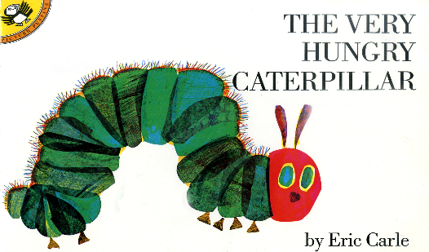  Read the Very Hungry Caterpillar with your child, encourage them to “read’ the book to you by repeating the key words and phrases in the book. Ask “ What Happened Next?”
I. Physical Development  a. Active Physical Play  1. Engages in physical activities with increasing balance, coordination, endurance and intensity  Benchmark a. Engages in active physical play for short periods of time | 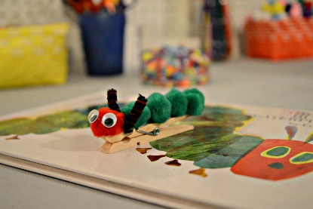  Fine Motor – practice pincher grip by picking up green, yellow and brown pipe cleaner “Caterpillars” and placing them on green “leaves” | You can copy this activity at home and allow children to use clothespins to pick up items around the house. Clip to paper plates, socks, blankets, go outside and clip to leaves, twigs etc.
V. Mathematical Thinking  E. SPATIAL RELATIONS  1. Begins to demonstrate an understanding of basic spatial directions through songs, finger plays and games  2. Manipulates objects by flipping, sliding and rotating to make them fit  F. MEASUREMENT AND DATA  1. Uses increasingly complex size words to accurately describe objects 2. Compares sets of objects by one attribute (e.g., sort by size) | Food and Nutrition- The Very Hungry Caterpillar food matching and sequencing game (left to right)  Taste Apples, pears, plums, strawberries, and Oranges, swiss cheese, pickles | Feed the Rainbow information will be coming home weekly. Encourage your child to try different foods to expand their pallet.  Practice small to big/Big to small sorting by using items in home. Family clothes, spoons, nesting mixing bowls, measuring spoons, towels
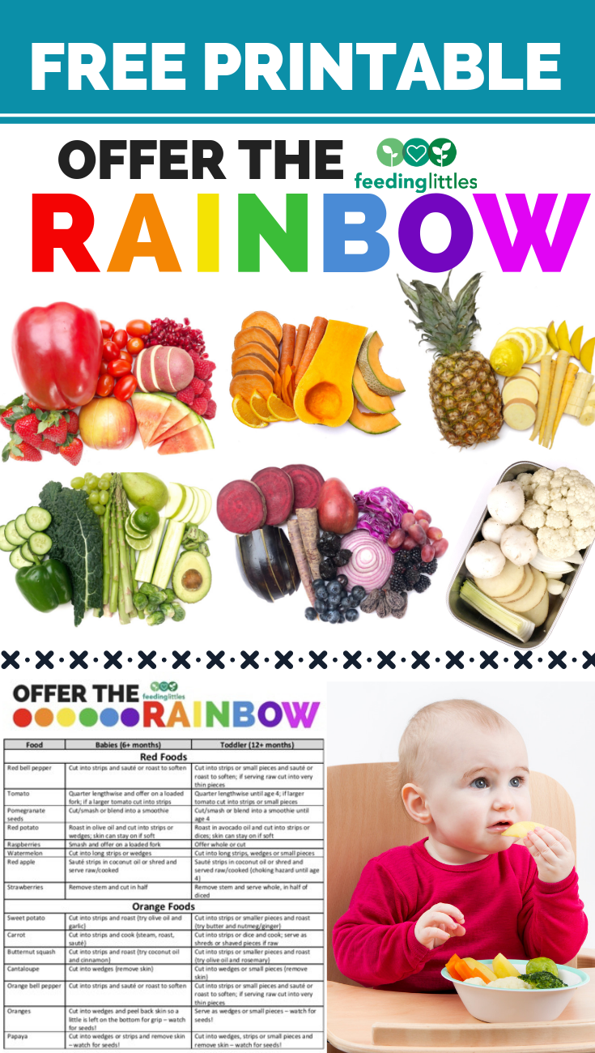
Parent Resource: Feed the Rainbow information

