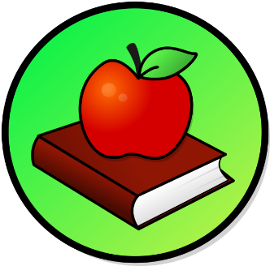
This Photo by Unknown Author is licensed under CC BY-SA
This Photo by Unknown Author is licensed under CC BY-SA

WEEKLY PEEK
Standard | Activity | At Home Extension
Science Standard: SC.K. N Nature of Science | Science Experiment Activity: Rainbow in a bottle/ Use mason jar, water, honey, and food coloring. | Go to the Website: Coolscienceexperimentsshq.com
Health& Food Standard: CTE. AFNR.68. Food.05.05 Read and interpret label and in making food. | Cooking Activity: Make some Jell-O cups w/ whip topping | Go to the Website: Pinterest.com/ 27 Jell-O activities
Physical Education Standard: PE.1. L. E Participate Regularly in physical activity. | Physical Activity: Do kids exercises inside or outside. | Go to the Website: Mommypoppins.com

Parent Resources and Information

