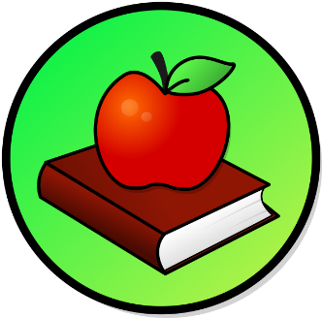
This Photo by Unknown Author is licensed under CC BY-SA
This Photo by Unknown Author is licensed under CC BY-SA

WEEKLY PEEK
Standard | Activity | At Home Extension
Science Standard: SC.K. N Nature of Science | Make Homemade Cinnamon Ornaments to hang on your Christmas tree. | Go to the Website: Wholefully>Home+ Garden
Science Standard: SC.K.P.9 Changes in Matter and Substance. | Make some Homemade Peppermint Playdough! (see recipe on the website, plus its safe, all natural & nontoxic) | Go to the website: frugalmomeh.com
Writing Standard: LAFS.2. Production and distribution of writing | Writing Activity: Write a poem about Christmas and share it with the class. | Go to the Website: www.wow4u.com>christmas-poems

Parent Resources and Information

