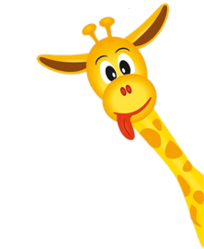
Peek at Our Week

Standard Focus | Activity | Home Extension Activity
VI. Scientific Inquiry  B. LIFE SCIENCE  Understands that all living things grow, change and go through life cycles | The children will have life cycle cards that they can put into order for the cycle of each of the two turtles which are sea turtles and gopher turtles. | Life cycle and interesting facts about both the sea turtle and the gopher turtle are attached. Have fun learning more about these turtles at home.
VI. Scientific Inquiry  B. LIFE SCIENCE  Notices the similarities and differences among various living things | We will be discussing the similarities and differences between a sea turtle and a gopher turtle. We will be making a chart of what we think are similar and the differences between the two types of turtles. | Take a look at a sea turtle live cam. https://marinelife.org/seaturtles/rehab/turtlecam/
VIII. Creative Expression Through the Arts  A. SENSORY ART EXPERIENCE  1. Combines with intention a variety of open-ended, process-oriented and diverse art materials | Each child will be making a floating sea turtle. We will be using green craft foam, fruit cup containers, paint, and glue. Once we have our turtles, made we will put the turtles in the water table to watch them float. | 