Peek at Our Week

Standard Focus | Activity | Home Extension Activity
V. Mathematical Thinking  A. Number Sense  5. Begins to predict the results of data collection | Sorting and weighing seeds.  Discuss the life cycle of a plant and graph the steps of plantings flowers. Have the children predict what will happen to seeds when you provide soil, sunlight, and water. What will happen if we deny plants those 3 things.  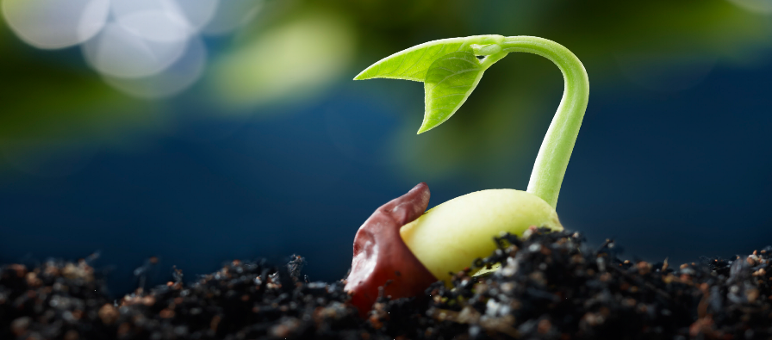  This Photo by Unknown Author is licensed under CC BY-SA | Parents may plant seeds at home with your child. Show pictures how plants start as seeds and what it takes
VI. Scientific Inquiry:  B. Life Science  a. Identifies characteristics of a variety of plants and animals including | Children will identify characteristics of plants including physical attributes (types of plants and trees and where they grow). They will use pictures to sort and categorize.  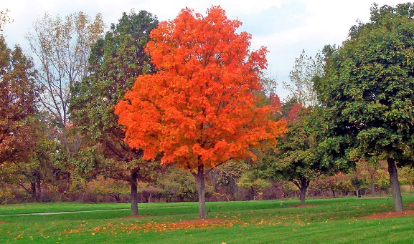 | Go on an outdoor nature walk. Identify different plants and trees. Tell your child that they are all considered living things and require sunlight, water, and soil to grow.
VI. Scientific Inquiry:  B. Life Science  c. Understands that all living things grow, change, and go through life cycles. | Planting seeds: The children will be planting their own seeds. | Plant seeds with your child. Allow them to water their seeds every day and record every day changes.

Parent Resources:

Other News:

