Peek at Our Week

Standard Focus | Activity | Home Extension Activity
Music and Movement  VIII Creative Expression Through the Arts  B. Music | Sing “Flutter, Flutter Butterfly.” (sung to the tune of Twinkle, Twinkle, Little Star)  Flutter, Flutter butterfly.  Floating in the bright blue sky.  Floating by for all to see.  Floating by so happily.  Flutter, Flutter, butterfly.  Floating in the bright blue sky.  With sign language for “butterfly” | Sing the Butterfly Song at home:  https://www.youtube.com/watch?v=XIYBecbJmgQ
Science and Discovery  VI. Scientific Inquiry  B. Life Science  1. Demonstrates knowledge related to living things and their environments | Make a book of the life cycle of a butterfly using pasta:  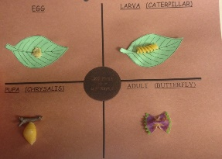 | Make a butterfly garden with your child.  https://www.mykidstime.com/things-to-do/how-to-make-a-butterfly-garden-with-your-kids/
Food and Nutrition  - Assists adults in preparing simple foods to serve to self. | Children will make “butterflies” using bananas, pretzels, raisins and carrot sticks.  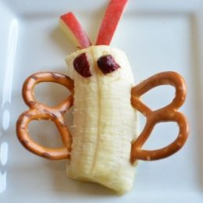 | Talk to your child about healthy food choices. Allow them to help you prepare the snacks.  https://www.healthline.com/nutrition/healthy-snacks-for-kids#TOC_TITLE_HDR_14

Parent Resources:

Other News:

