Peek at Our Week

Standard Focus | Activity | Home Extension Activity
V. Mathematical Thinking  Measurement and Data:  Represents, analyzes, and discusses date. Begins to predict the results of data collection. | Children will be observing and measuring plants that have sprouted from seeds. We will analyze and discuss the data on a graph.  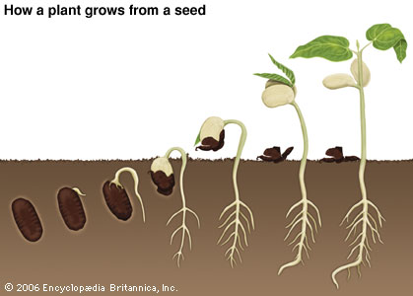  This Photo by Unknown Author is licensed under CC BY | Make a graph at home to measure seeds that have grown into plants. Discuss this data with your child. Use tallies and pictures. Show your child how to use a ruler to measure their plant.
Science and Discovery  VI. Scientific Inquiry  - Demonstrates knowledge related to living things and their environments | Butterflies:  The life cycle of a butterfly is truly amazing. We will learn that butterflies have four life stages, the egg, the caterpillar (larva), the chrysalis, and the adult butterfly  Read: Circle of Life: Life Cycle of a Butterfly. 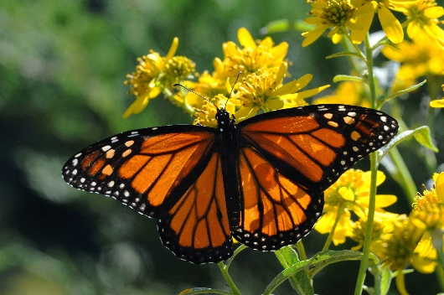 | Talk about butterflies with your child. Let them know that they are insects with six legs and three separate parts to their body. The following website has wonderful facts about butterflies:  https://www.coolkidfacts.com/butterfly-facts/
Fine Motor Development:  - Shows hand control using various drawing and art tools with increasing coordination | Butterfly art using watercolor/droppers and coffee filters.  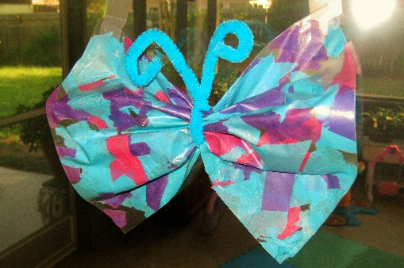 | At home: Paint bow tie pasta pieces to turn them into cute little butterflies. This will allow children to be creative, and also strengthen fine motor skills.

Parent Resources:

Other News:

