Peek at Our Week

Standard Focus | Activity | Home Extension Activity
VII. Social Studies  C. Individuals and Groups  2. Explains the roles of groups within a community | Block and Construction:  Children can build cities and farms. They can use people and animals to live in their communities. They will be able to explain the roles of groups within a community. | Give children jobs to do at home. This provides them a sense of being an individual. Explain to them how important they are to creating your community at home and how their job is necessary.
VII. Social Studies  - Culture  2. Identifies the ways self is similar to and different from peers and others. | Dramatic Play:  “General Country Store” The children will be learning about living things. Part of that is how we get our food to live. They can pretend to have a country store where they feed animals, feed people, and categorize food.  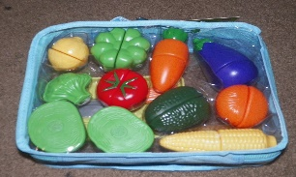  This Photo by Unknown Author is licensed under CC BY | Show your child pictures of living and non-living things. Ask them to identify what “living” and “non-living” mean. What do people and animals need to live and grow?
VIII. Creative Expression Through the Arts | The Children will be creating art that reflects life on earth using stencils, crayons, pencils  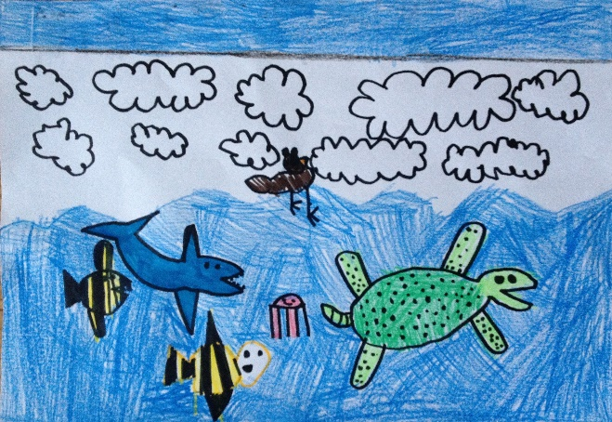 | Talk to your child about recycling and why we need to take care of our community. The following is a YouTube video about recycling.  https://www.youtube.com/watch?v=OasbYWF4_S8

Parent Resources:

Other News:

