Peek at Our Week
Standard Focus | Activity | Home Extension Activity
V. Mathematical Thinking  F. MEASUREMENT AND DATA  2. Identifies measurable attributes such as length and weight and solves problems by making direct comparisons of objects | Read the Grouchy Ladybug. On strips of paper, measure off the size of some of the animals that the Grouchy Ladybug encounters. Have the children draw a picture of the animal on the appropriate length strip, then find items around the class that are near the size of each animal. | Build with Legos and measure with a ruler the different sizes of what you made.
VI. Scientific Inquiry  B. LIFE SCIENCE  Benchmark c. Understands that all living things grow, change and go through life cycles | Ladybugs go through a life cycle to develop into an adult ladybug. We will discuss the life cycle of the ladybugs as a class. Each child will get to put a booklet together in order that the life cycle goes in. After the booklet is put together each child will get to color the pictures. | Life cycle of a ladybug video. https://www.youtube.com/watch?v=ws_D5nXOAJg
V. Mathematical Thinking  A. NUMBER SENSE  2. Counts and identifies the number sequence “1 to 31” | 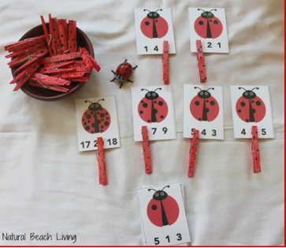  The children will be given cards which have a picture of a ladybug on them. Each with a different number of dots. Along the bottom of each card are three numbers. The children need to clip a clothespin on to the number which represent the correct number of dots on the ladybug. | Take a calendar out at home and count the days that are in the month May.

