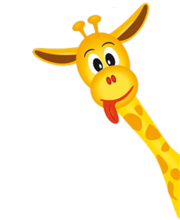
Peek at Our Week

Standard Focus | Activity | Home Extension Activity
Understands that all living things grow, change and go through life cycles | We will be discussing the life cycle of a butterfly. There are four steps to the cycle of a butterfly. The steps are egg, caterpillar, chrysalis, butterfly. We will have sequence cards of these steps and we will have the children put the cards in the correct order of the life cycle. | Sing the Butterfly Ballad with your child that is attached to the weekly peek.
A. NUMBER SENSE  1. Subitizes (immediately recognizes without counting) up to five objects | We will use our bug counters to count the bugs, then sort them by type of bug, and their colors | You may use cups or a towel to hide what you would want your child to count. This might include Legos, cars, pom poms, cereal. When you begin you will cover the object you would like them to count and pick up the towel or cups to reveal the number to your child and then cover it back up and ask them how many objects they counted.
B. LIFE SCIENCE  Benchmark a.  Identifies characteristics of a variety of plants and animals including physical attributes and behaviors (e.g., camouflage, body covering, eye color, other adaptations, types of trees and where they grow) | We will be discussing how butterflies use their camouflage to disguise themselves from birds and other insects/animals that like to eat butterflies. | A page of pictures of the camouflaged butterflies is attached to this weekly peek. Have your child try and pick the butterflies out while they are camouflaged. Talk about how the butterfly used color and patterns as camouflage.

