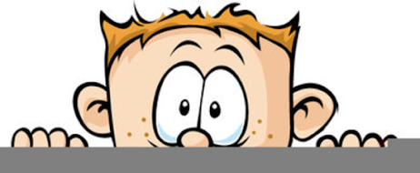

Peek at Our Week
Standard Focus | Activity | Home Extension Activity
- Faith Formation: Fruits of the Spirit - Peace | 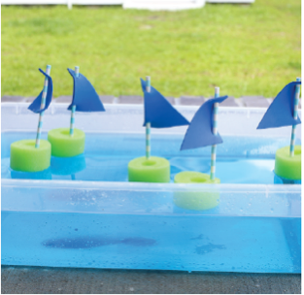  Jesus Calmed the Storm  The children will be read the story of Jesus calming the sea. Then they will be given a basin filled with some blue water, a “boat”, a few very small foam squares and two spoons. Using these objects, the children will act out the story. | Jesus Calms the Storm  Here’s a link to a video of the story of Jesus calming the storm on YouTube. Please watch the video before sharing it with your child.  The focus for this story is that Jesus has power over all things, even waves and storms! So, He can bring us peace when we are scared or anxious.
- Counts and identifies the number sequence “1 to 10”  - Begins to demonstrate one-to-one correspondence up to 10 during daily routines  - Identifies the last number spoken tells “how many” up to five (cardinality) | Using counters and blocks  Put 8 frogs on the block  Then ask, “How many frogs are on my block?”  Then finds the corresponding number card. | Remember that you can count anything with your child: the number of blueberries they can have for snack, the number of shoes in their closet, the number of dolls they have. The important part is just to count. Get number magnets for your refrigerator and some plain circle ones and have your child put the correct number of circle magnets under the number.
- Expresses, identifies and responds to a range of emotions  - Identifies complex emotions in a book, picture or on a person’s face (e.g., frustrated, confused) | Matching Emotions game  Layout a variety of images showing different facial expressions. Ask the children to find ones that match, such as two sad people. | Identifying emotions by looking a person’s face is a skill a child learns through experience. When reading books to your child, be sure to point out faces with display emotions. Ask your child what they think the person is feeling and why. Talking about emotions with your child helps them to identify and handle their own emotions.
Parent Resources:

