Peek at Our Week
Standard Focus | Activity | Home Extension Activity
- Demonstrates knowledge related to living things and their environments  - Observes and explores a variety of plants and animals and their environments  - Begins to notice the similarities and differences among various living things | 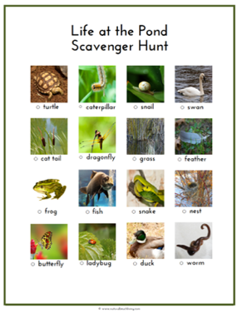  Working in small groups, the children will be asked to cover the picture of “duck”. Calling each species until all are covered | You could extend this activity at home by going on a real scavenger hunt in your yard, park, pond, or beach.
- Expresses, identifies and responds to a range of emotions  - Identifies complex emotions in a book, picture or on a person’s face (e.g., frustrated, confused) | Working in small groups, the children will be asked to choose faces showing different emotions. | Have your child look in a mirror and make faces showing different emotions.  Have your child look at your face and have them tell you what emotion you are displaying on your face.
- Subitizes (immediately recognizes without counting) the number of objects in a set of four objects  - Counts and identifies the number sequence “1 to 10”  - Counts sets constructed by the teacher to five and beyond  - Constructs and counts sets of one to five and beyond | Working in small group, the children will be asked to construct groups of sea creature counters into groups. They will also be asked to count groups of counters which have been put into groups by the teacher. Additionally, the teacher will make a set of counters under a cloth so the children can’t see it. She will take the cloth off and a few seconds later replace the cloth and ask the children how many counters they saw. | Practice counting items at your house. Anything from cars, dolls to the number of peas on your dinner plate.  Try counting items that are placed close together and spread far apart.
Parent Resources: We are beginning our last unit of the year! Ponds and Oceans is the theme for the last nine weeks of our time together. Our Faith Formation focus for this unit is the Fruit of the Spirt. I have attached a poster for you to hang up at your home. On Wednesdays, we will be having water play. Please dress your child in clothes which will dry quickly if they happen to get wet.

