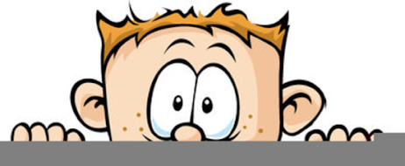

Peek at Our Week
Standard Focus | Activity | Home Extension Activity
- Uses imagination and creativity to express self with intention using a variety of open-ended, process-oriented and diverse art materials | Painting with cars  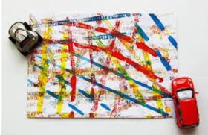 | Painting with cars is fun. Let your child run the car through the paint and then onto the paper.
- Counts and identifies the number sequence “1 to 10”  - Recognizes and names typical shapes (circle, square, triangle) | Driving Cars on Number Roads  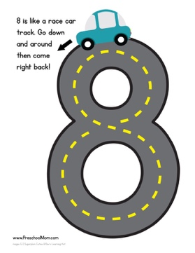 | Using masking tape, make letters, numbers of shapes on the floor and let your child drive their cars along them.
- Identifies basic physical characteristics (e.g., landmarks or land features)  - Increasingly coordinates hand and eye movements to perform a variety of actions with increasing precision  - Coordinates the use of arms, hands, fingers to accomplish tasks with hand-eye coordination when participating in routines, play and activities (e.g., painting at an easel, placing simple pieces of puzzle, folding paper) | Magnetic Vehicles STEM Tray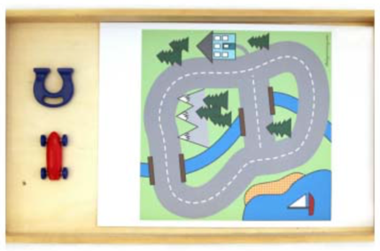  The children will use the magnet to move the car around the course. | Exploring with magnets is exciting for children. Give your child a magnet and some metal and non-metal items and let them experiment. Put some paper clips into an empty water battle and see if the magnet can lift them up.
Parent Resources: Focus for the week is cars and trucks along with circles, cubes, squares and rectangles.

