Peek at Our Week
Standard Focus | Activity | Home Extension Activity
- Uses imagination and creativity to express self with intention using a variety of open-ended, process-oriented and diverse art materials Coordinates the use of hands and fingers  - Increasingly coordinates hand and eye movements to perform a variety of actions with increasing precision | Rocket Craft  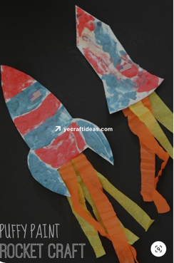 | 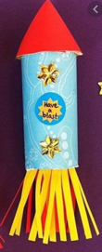  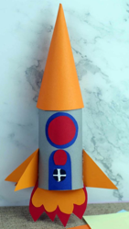  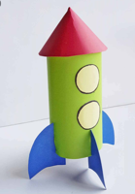  Try making a rocket out of a toilet paper or paper towel tube. Here are a few examples.
- Demonstrates emerging problem-solving and decision-making skills  - Uses props to represent simple tools through play.  - Explores and identifies simple machines through play (e.g., ramps, gears, wheels, pulleys and levers) | Exploring ramps: The children will experiment with building ramps using these items shown below and large and small blocks with different surfaces. They will record their results.  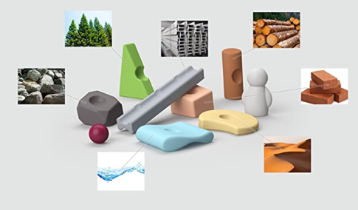 | 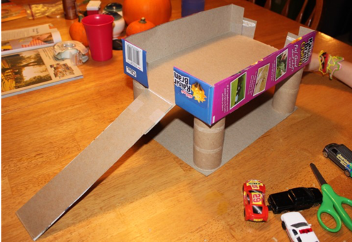  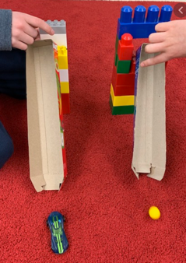  Ramps can be made out of many normal household items such as cereal boxes, wrapping paper tubes and larger cardboard boxes. Try experimenting with the height of the ramp. Record which cars or balls go the farthest and the fastest.  Parking garage or doll house made out of 4 toilet paper tubes and a cereal box
Parent Resources: Focus for the week is space travel along with cylinders and cones.

