Peek at Our Week
Standard Focus | Activity | Home Extension Activity
- Uses imagination and creativity to express self with intention using a variety of open-ended, process-oriented and diverse art materials Coordinates the use of hands and fingers  - Increasingly coordinates hand and eye movements to perform a variety of actions with increasing precision | 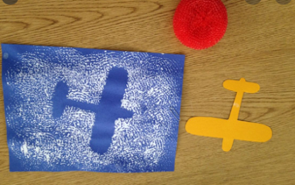  Airplane Craft: The children will use place the stencil on the paper and using the plastic woven scrubber stamp clouds with white paint. The stencil will then be removed to reveal the shape. | Stencils are easy to make just cut the shape out of card stock or any box. Use a rolled piece of tape to secure the stencil to the paper. Stamp paint on to the paper using any household item such a sponge, balled up tin foil, or broccoli. Remove the stencil to see the object.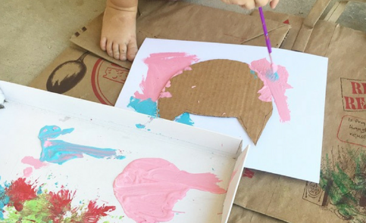
- Demonstrates emerging problem-solving and decision-making skills  - Uses props to represent simple tools through play.  - Explores and identifies simple machines through play (e.g., ramps, gears, wheels, pulleys and levers) | Exploring gears  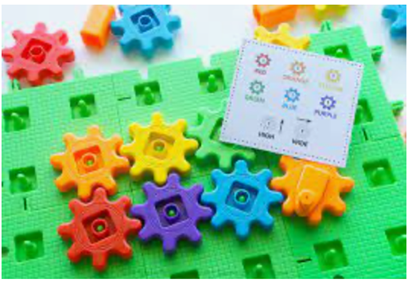 | 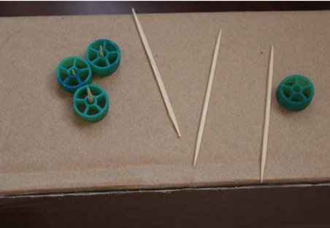  Use wagon wheel pasta, toothpicks and a box to make your own gear exploration station.
- Demonstrates emerging problem-solving and decision-making skills | During this unit I have been creating small problems for the children to solve. Such as no train tracks in the block center. Then as a class we come up with solution to the problem. We could look for the tracks. We could use blocks as track. We could put tape on the floor and use it as the track. We could play with the cars instead. | You can create small problems at home for your child to solve. Such as no bubble bath. You could use liquid soap or shampoo instead or take a bath without bubbles or take a shower. Creating a problem for your child to solve when you have the time and energy to help them find a solution will teach your child how to cope with problems that just pop up throughout the day.
Parent Resources: Focus for the week is air travel along with ovals and spheres

