Peek at Our Week
Standard Focus | Activity | Home Extension Activity
- Uses imagination and creativity to express self with intention using a variety of open-ended, process-oriented and diverse art materials | Paint While Riding the Tricycles  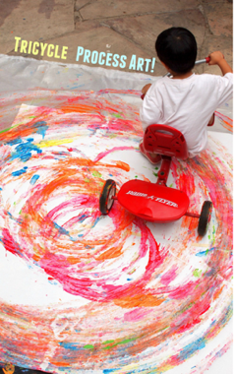 | Get adventurous and paint with your bike or tricycle, but not with paint with water. Wet an old towel and let your child drive over the towel and onto your driveway making tracks as they go.
- Recognizes and names typical shapes (circle, square, triangle)  - Describes familiar people and objects in the environment | Discovering shapes on the playground  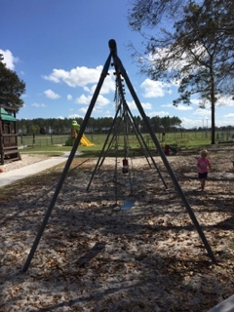 | Take a walk around your house or neighborhood and hunt for shapes. Take pictures of the shapes to share with other family members.
- Identifies basic physical characteristics (e.g., landmarks or land features)  - Increasingly coordinates hand and eye movements to perform a variety of actions with increasing precision  - Coordinates the use of arms, hands, fingers to accomplish tasks with hand-eye coordination when participating in routines, play and activities (e.g., painting at an easel, placing simple pieces of puzzle, folding paper) | Shape Clip Cards  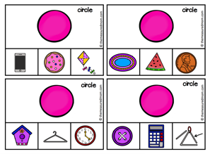 | Cut over different shapes. Show your child a shape and ask them to find an object or picture with that shape.
Parent Resources: Focus for the week is bikes and motorcycles along with circles, cubes, squares and rectangles.

