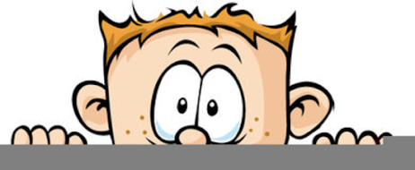

Peek at Our Week
Standard Focus | Activity | Home Extension Activity
- Matches a wider variety of shapes and orientations | 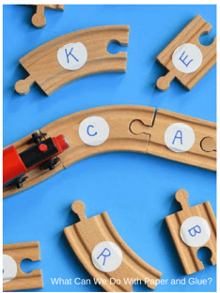  ABC Train Track Game  The children will pick a card with a letter on it and then find the matching track piece. While playing this game, we will look for shapes which make up the letters. | Put stickers with number, letters or shapes on your MagnaTiles, MegaBloks or Duplo Blocks and make a game. You could have your children put the letters or number in order, spell their name, match shapes, just use your imagination.
- Recognizes and names typical shapes (circle, square, triangle)  - Matches a wider variety of shapes and orientations | Sponge Paint Train  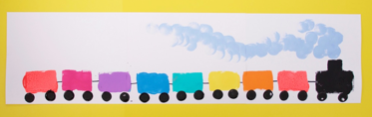 | Let your child make a train at home. Use the attached shapes and some glue and sit back and see what they create. Talk about the shapes they are using; how do they look the same and different.
- Recognizes and names typical shapes (circle, square, triangle) | Which Shape Does Not Belong Game  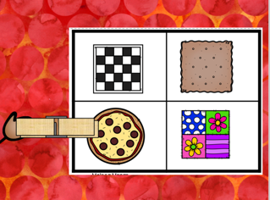 | Noticing the differences between objects is an important skill. During your normal routine start to point out differences such as Dad’s car has four doors and Mom’s has two. Or ask your child what is different between the two objects. Also put out three or four objects making sure that one does not belong and ask your child to tell you which one is wrong and why. Don’t let them just point at the object.
Parent Resources: Focus for the weeks is trains along with circles, cubes, squares and rectangles.

