Peek at Our Week
Standard Focus | Activity | Home Extension Activity
- Counts and identifies the number sequence “1 to 10” | 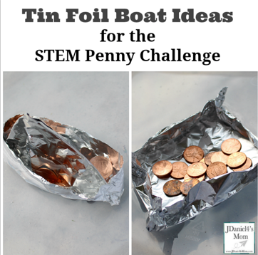  Make a tin foil boat and then count how many pennies it takes to sink the boat. | Repeat this activity at home with your child. Make three tin foil boats which are designed differently. Record how many pennies it takes to sink each boat. Talk about which one needed the most pennies and the least pennies.
- Explores three-dimensional shapes in the environment through play | Building Boats  The children will use a variety of materials to make boats. 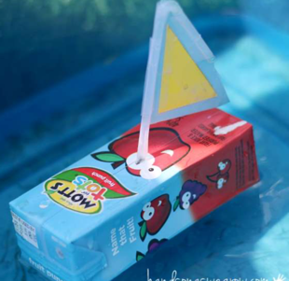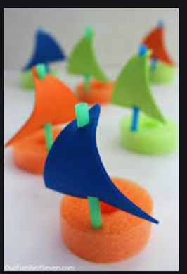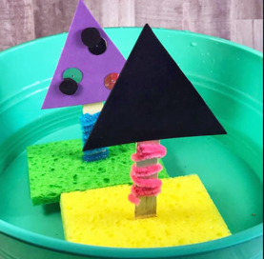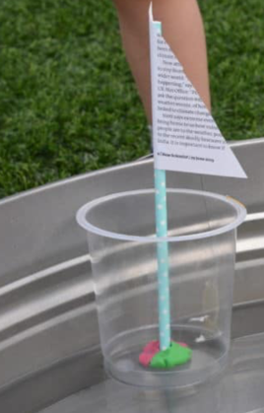 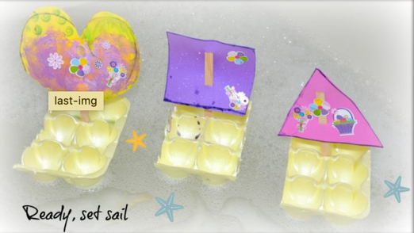 | Try making some boats at home. An egg carton, juice box, plastic cup, sponge or anything else that floats can be made into a boat. When making the boats talk about the shapes you are using. Then take them to the bathtub and test them out!
Parent Resources: Focus for the weeks is boats, triangles and rhombuses (diamonds).

