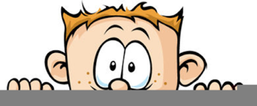**Peek at Our Week**

|  |  |  |
| --- | --- | --- |
| **Standard Focus** | **Activity** | **Home Extension Activity** |
| * Uses size words to label objects | Size Sequencing cards | You can practice sequencing by size with everyday objects. Gather sticks or rocks outside and then place them in order from smallest to largest. This same activity can be done with socks, cars, stuffed animals, etc. |
| * Counts and identifies the number sequence “1 to 10” * Identifies the last number spoken tells “how many” up to five (cardinality) * Constructs and counts sets of one to five and beyond | Counting and Sorting Fish counters into foil pie dished with water | Pull out a pair for dice and let roll child roll them, count the number of dots and then gather that same number of a small toys, pieces of pasta, beads, etc. Talk to them about which die has the most dots or are they equal. |
| * Faith Formation: Fruits of the Spirit - Joy | White furniture in a room  Description automatically generated Fruits of the Spirit: Joy  Put a teaspoon or less of baking soda into the balloon. Fill the water bottle about a ¼ of the way with vinegar Put the balloon on to the water bottle and shake the balloon so the baking soda falls into the bottle. Then watch the balloon fill up. I suggest doing this activity outside in case you get the proportion incorrect, or the balloon comes off of the bottle! | Please try this experience at home. The child ren just love it and only get to see it once at school.  While doing the experiment, talk about how when you have Jesus is your heart, you are filled with His joy and nothing can take that away! |

**Parent Resources:** This week our focus is Joy. Here is a link to a song on YouTube which the children are learning. [Fruit of the Spirit Song](https://www.youtube.com/watch?v=xWoWDdeD-ns)