Peek at Our Week

Standard Focus | Activity | Home Extension Activity
VIII. Creative Expression Through the Arts  A. SENSORY ART EXPERIENCE  1. Uses imagination and creativity to express self through open-ended, diverse and process-oriented art experiences with intention. | Small Group:  Muddy Pigs Arts/Craft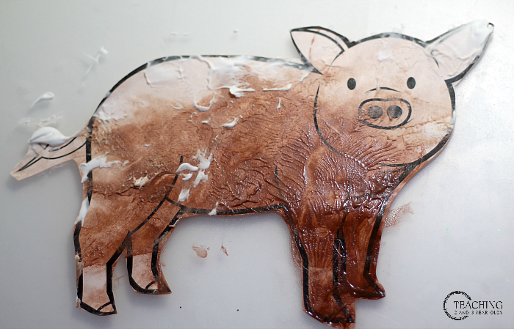  The children will put a picture of a pig inside a large gallon bag. Kids will put brown paint and shaving cream inside the bag and squish it around. Afterwards, the children will take their pigs out of the bag and hang them dry. | With your child, make some “Dirt Dough.” It looks and feels like dirt, but it is germ free and clean.  Ingredients:  - Baking soda  - Black food coloring  - Water  Method:  - Begin by pouring the desired amount of baking soda in a large bin or container.  - Add 2-3 spoons of black food coloring  - Slowly begin to add water and mix, slowly adding more until desired amount is achieved. You want the dough to be damp and moldable but not too wet.  - Once combined, add some cups and small toys and have fun.
I. Physical Development  A. HEALTH AND WELLBEING  c. Personal Care Routines  1. Responds to and initiates care routines that support personal hygiene. Carries out some steps of own personal hygiene routines with specific adult guidance or demonstration.  F. EMERGENT READING  1. Shows motivation for and appreciation of reading  Bookmark a.  Shows increased interest in print and books. | “Mrs. Wishy-Washy’s Farm” by Joy Cowley  This book teaches children about three different animals which is a pig, a cow, and a duck. Mrs. Wishy-Washy is obsessed with cleanliness and her attempts to keep the animals from getting dirty. | Talk to your children about the importance of handwashing in their daily routine. Practice hand washing with your child while singing the “Tops and Bottoms” song for 20 seconds to wash hands thoroughly.  Sing in the tune of “Are You Sleeping?” (Frere Jacques)  Tops and bottoms, tops and bottoms,  In between, in between,  Scrubba, dubba, dubba,  Scrubba, dubba, dubba,  Now they’re clean, now they’re clean.
c. Fine Motor Development  1. Demonstrates increasing precision, strength, coordination and efficiency when using hand muscles for play and functional tasks  Benchmark a.  Coordinates the use of hands and fingers. | Small group:  Dirt Cups  The children will be making a fun and delicious dessert for afternoon snack. | You and your child can make your own “Dirt Cups” at home for a fun inside activity.  Ingredients:  - 2 cups cold milk  - 1 package chocolate instant pudding  - 8 ounce container of cool whip  - 1 package of Oreo cookie  Directions:  - Pour milk into large mixing bowl  - Add pudding mix  - Beat with whisk until well blended (1-2 minutes)  - Let stand for 5 minutes  - Stir in whipped topping and half of the crushed cookies  - Place one tablespoon crushed cookies into bottom of cups  - Fill cups ¾ full with pudding mixture  - Refrigerate for one hour  - Decorate with candy  - Enjoy!

