Peek at Our Week
Standard Focus | Activity | Home Extension Activity
- Uses senses to observe and experience objects and environment  - Uses tools in scientific inquiry | Make Grape Juice and eat grapes.  Talk about the Last Supper when Jesus drank wine/grape juice with his disciples. | The following is a link to a short-animated video about the Last Supper. Please remember to preview all videos before sharing them with your child.  The Last Supper
- Develops sense of identity and belonging through exploration and persistence  - Continues sustained independent play and participates in more planned group activities | Easter Story Puzzles  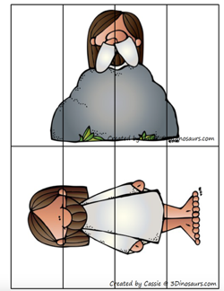 | This style of puzzles is extremely easy to make at home. Just take any picture and cut it into as many strips as you like. Your child will enjoy putting together pictures of familiar people, animals and objects.
- Uses senses to observe and experience objects and environment  - Uses tools in scientific inquiry | 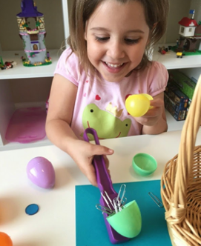  Easter Egg Magnet Exploration | Magnets are fun and magical for a small child to explore. Fill plastic eggs with items which are magnetic and not. Give your child and magnet and let them discover which ones will be attracted to the magnet and then let them open them up to discover what was inside.
Parent Resources: The focus for this week is Jesus as the True Vine or Jesus is the vine and we are the branches.

